

Neutral Citation Number: [2019] EWCA Civ 150 Case No: A3/2018/0209

IN THE COURT OF APPEAL (CIVIL DIVISION) ON APPEAL FROM THE UPPER TRIBUNAL, TAX AND CHANCERY CHAMBER Upper Tribunal Judge Elizabeth Cooke UT/2017/0042
Royal Courts of Justice Strand, London, WC2A 2LL

Date: 14/02/2019
Before:

LORD JUSTICE McCOMBE
LORD JUSTICE DAVID RICHARDS
and
LORD JUSTICE NEWEY
- - - - - - - - - - - - - - - - - - - - -
Between:

SHIRLEY ANN THORPE | Appellant
- and -
HARALD NOBERT FRANK  LESLEY FRANK | Respondents

- - - - - - - - - - - - - - - - - - - - - - - - - - - - - - - - - - - - - - - - - -

Geraint Wheatley (instructed by Harland & Co.) for the Appellant Edward Denehan (instructed by Gregsons) for the Respondents

Hearing date: 24 January 2019
- - - - - - - - - - - - - - - - - - - - -

Approved Judgment

Lord Justice McCombe:

(A) Introduction
- This is the appeal of Mrs Shirley Thorpe from the Order of 7 November 2017 of the Upper Tribunal (Tax and Chancery Chamber) (“UT”) (Upper Tribunal Judge Elizabeth Cooke). By that order Judge Cooke allowed the appeal of the Respondents, Mr Harald Frank and Mrs Lesley Frank from the Order of the First-tier Tribunal (“FTT”) (Tribunal Judge Hugh Jackson) of 23 October 2016.
- As a result of Mr and Mrs Franks’ successful appeal, the UT ordered that Mrs Thorpe’s then registered title to property and land adjacent to 9, Harcourt Close, + (“No. 9”) under title number NYK421739 be altered by removing from it land registered under that title and adding the same to the registered title of Mr and Mrs
Frank to the property and land known as 8, Harcourt, Close (“No. 8”) registered under title number NYK129935. The order directed that title number NYK421739 be closed. I was at one stage concerned as to whether the order of the UT had been inaccurately drawn up. The point was raised in the initial draft of this judgment circulated to the parties. It seems likely, following an explanation from counsel, that my concern was unjustified. However, I would ask counsel to liaise with one another to ensure that this court can make an order on the appeal that gives correct directions to the Land Registry. (B) Background Facts
- No. 8 and No. 9 are neighbouring semi-detached bungalow properties in Harcourt Close, which is part of an area of residential properties built in the mid-1960s. Mrs Thorpe’s principal property, No. 9, obtained first registration on 3 December 2014 under title number NYK419739.
- Mrs Thorpe acquired No. 9 on 17 January 1984 from a Mrs Marjory Asher; Mrs Thorpe had previously lived at No. 9 as Mrs Asher’s tenant. Mr and Mrs Frank became registered owners of No. 8 on 28 May 2012, having obtained the property by gift from Mrs Frank’s mother, Mrs Marjorie Sutherland, who had resided at No. 8 since about 1995.
- The situation of the two properties can be seen by reference to the title plan of No. 8, a copy of which is annexed to this judgment. As shown, the land comprised in the title of No. 8 was, as Mr Denehan for Mr and Mrs Frank conveniently called it, “jug shaped”. The title of No.9 lies to the south-west of No. 8, below it on the plan and to the right of the “jug spout” of No. 9’s registered title.
- The dispute arose from Mrs Thorpe’s claim to have acquired, by adverse possession, part of the land included in the title to No. 9. The relevant land is a triangular plot forming the “jug spout” (or part of it) to which I have referred. The disputed plot is usefully illustrated by a sketch plan (not to scale) which was attached to the judgment of the UT. I annex a copy of that plan to this judgment also. It is to be noted that this plan has certain flaws. The boundary to the left should be shown as a continuation to the top of the plan of the line C-D. If that line is so continued, the garage shown as “Number 9 garage” would be correctly described as “Number 7 garage” and there should be shown to the right of it on the plan a further garage attached to that one, which is “Number 8 garage”. That is, there is a pair of connected garages on that spot, serving
No. 7 and No. 8 respectively. As can be seen from the title plan already annexed, a garage serving No. 9 is to the rear of that house and somewhat to the south of it. However, the garages have little, if any relevance to the present dispute.
- Both the Tribunals and this court have been assisted by a number of photographs which are uncontroversial. I append one of these to this judgment for illustrative purposes only. On that photograph, the two garages, serving No. 7 and No. 8, can be seen. No. 8 and No. 9 are to the right of the picture. The disputed land is about half the area laid out in paved squares in the foreground. It is that half which would lie to the left of an imaginary line running from the corner apex nearest the photographer and continuing to the point where the fence meets the two properties. That part of the paved land to the right of the imaginary line is within the paper title of No. 9. The part of the paved area to the left of that imaginary line is the disputed land. I will return to the fence, shown on the picture, later in this judgment. The paved area, with its brick edged sides and similarly edged squares, has been known in the proceedings as “the apron”.
- Mrs Thorpe applied to the Land Registry for registration as freehold proprietor of the disputed part of the apron, as part of her title to No. 9, on the basis of a title acquired by adverse possession. The statement submitted by Mrs Thorpe in support of that application included the following:
“The area in front of my house was paved with concrete paving slabs by the previous owner, a Mrs Marjory Asher, in a rectangular shape, believing the land to be hers. It had a small garden in the centre. The property was then sold to me in this state on 17 January 1984 and no mention was made to me of any other access across the land, nor that the land belonged to the title of another. Accordingly, in 1985, I decided to have the area repaved and this paving kept to the existing area, at least where it adjoins the neighbour’s gravelled area perpendicular to the front of my house. I note that the neighbour never questioned this then or until now, and would have had to have made reference to it at the time of first registration of their own property, but clearly did not. In the intervening time, no person or vehicle ever crossed the land in question from 1985 to date, during which time I have parked my car in the space. Given the space that the neighbour at 8 Harcourt Close has to access garages and the property, this is not surprising. … There was, prior to 1984, a concrete “lip” around the paved area which clearly demarcated the area adversely possessed, such that it is “obvious” to a third party that the area forms the area attached to 9 and further that it is clearly not a roadway access to any other property. The new paving again makes it clear that the land is being dealt with as my own and not for some other benefit or access route.”
The application was referred to the FTT by the Registry and Mr and Mrs Frank became respondents to it.

(C) In the First-tier Tribunal
- In evidence before the FTT, Mrs Thorpe supplemented her written statement provided to the Registry. She said that when she was a tenant on No. 9 and up to the time of her purchase from Mrs Asher, there was an edged stone kerb around the apron area with different tiles or flagstones laid over that area. There was a flower bed in the middle. She decided to repave the apron and her son, Mr Steven Thorpe, did the necessary work in about 1986. She said that it was those tiles/flags and bricks that have remained on the apron ever since and which can now be seen on the photographs.
- Mr Thorpe gave evidence to the FTT that he was a builder by trade. He said that when his mother bought No. 9 the apron area was paved with 2 foot square flags, edged with a brick set, and that the whole area was raised by some 2 ½ inches from the surrounding surfaces. There was a small area of open soil in the middle in which a bush had been planted. He said his mother power washed these flags and tended the central planted area. However, he said, his mother wanted the apron area levelled down, removing the 2 ½ inch lip, to avoid damaging her car tyres. Accordingly, he had gone with his mother to a builders’ merchant where they had chosen buff coloured paving flags, 600 mm. square in dimension, and burnt brown brick sets to form the edging and to break up the paving appearance. They had purchased “vehicle-grade” paving so that it would be suitable for vehicles to drive over. He then removed the old flags, reduced the level of the area by digging it out and restored it with hard-core. He laid the new flags and set the brick edging. He said that the work was done in 1986. It became common ground that, whenever the work was done, it took about two weeks to complete.
- The major factual dispute before the FTT was as to whether Mr Thorpe’s evidence, as to the date on which he did this work, was correct. He said it was done in 1986. The Franks and their witnesses said that the work was done much later in 2009. The FTT accepted the evidence of Mrs Thorpe and of Mr Steven Thorpe on this point and found that the work had been done in 1986. The FTT also found that there had indeed been some form of paving covering the apron in the period before 1986 and that the earlier paving was bordered with a concrete lip. Those points were not contested on the appeal to the UT and they have not been contested in this court. It is not necessary to say more about the evidence given on those matters, which is set out very fully in the FTT decision.
- That decision contains some material as to the use of the apron after the new paving was laid. Mr Thorpe said that his mother had regularly parked upon it and had regularly power-washed it, wearing out a number of washers in the process. She said that she also regularly cleared the area of litter and weeded it. The Franks said that they had regularly driven over it on visits to Mrs Sutherland. They said that in 2012, shortly after their acquisition of No. 8, they had had works done there and that contractors’ vehicles had also crossed the apron bringing materials to their property. The contractor, a Mr Rhodes, confirmed this, saying that he had done this for about 6 weeks between March and May 2012. A flower pot on the apron had been broken in the process.
- In 2013, Mrs Thorpe erected the fence that we see in the photograph. It was that action that triggered the present dispute. Of some importance to the UT decision, there is one passage in the FTT’s judgment as to Mrs Thorpe’s reasons for erecting this fence. The passage is to be found in paragraph 26 of the FTT decision as follows:
“26. As to the construction of the fence she said that she had not thought of putting a fence around the land and that the purpose of putting up the fence was to stop persons crossing over the land; she did not have control before the fence was erected. Before the fence was erected a number of pots had been placed on the apron but these were not placed right to the edge. The purpose of placing such pots was to show that she had control of the land. Before those pots were put in place there were no other obstructions.”
- Judge Jackson in the FTT found, however, that Mrs Thorpe had achieved the necessary “factual possession” of the apron and had the necessary intention to possess it from at least 1986 and that her claim was, therefore, established. The necessary intention to possess is no longer disputed by the Franks. Judge Jackson’s finding as to factual possession appears in paragraph 67 of his decision as follows:
“67. I bear in mind the particular location of the respective properties in this matter. It is an urban environment involving relatively small parcels of land albeit such parcels are of considerable importance and significance to their owners. As such, changes to the structure of such land may have major consequences to its utility to its owner. In my view the construction of paving upon the disputed land comprised in the title of the Respondents was an act giving rise to factual possession. Whatever may have been the surfacing at the front of No. 9 prior to 1986, as I have found, when in that year the surface was dug out and refilled with stones, on which were laid paving slabs and bricks, into an apron of approximate rectangle in shape, there was a taking into the possession of No. 9 of all of the land comprising that shape; it could not be characterised as treated by the Applicant as partly her neighbour’s land. Such land was treated by the Applicant as being her own. Whilst it remained possible for access and egress to No. 8 to be enjoyed across the paving, and this may well have occurred on occasions, I find that the paving comprised physical possession of the disputed land. I do not think that such use amounted to the taking of possession by the Respondents. The Applicant’s possession was manifested also, albeit to a lesser extent, by her parking cars on the same on occasions, cleaning the surface with a pressure washer and tending to weeding.”

(D) In the Upper Tribunal
- Permission to appeal to the UT was granted by Judge Cooke by a decision of 10 April 2017. She found that there were doubts and uncertainties as to the evidence and as to the FTT’s findings on the issue of possession after 1986 and directed a partial re-hearing
“… but only of evidence relating to possession of the disputed land from 1986 after the paving was laid to 2012…”.
- The written arguments of the parties before us contained submissions directed to whether or not this procedure so ordered by Judge Cooke was a correct one or not. Happily, it was not necessary for this dispute to be pursued on the hearing of the appeal to this court as the parties directed their arguments to the merits of the case, based upon
what had become uncontested primary facts that had emerged from the hearings before both Tribunals. For my part, however, I had considerable doubts as to whether the wellintentioned, partial re-hearing procedure adopted by Judge Cooke here was a desirable one and I would not wish to leave the case without saying that I consider that the UT should hesitate long before adopting such a procedure in future cases.
- It seems to me that, on hearing an appeal of the present character, it would be a better course, for the UT to adopt a traditional appeal procedure and deal with the case on the facts as found in the FTT. As will be seen from this judgment, I consider that the findings of fact made by the FTT were entirely sufficient for the purpose of deciding the appeal. If that were not the case and there had been some paucity of evidence, the UT would simply decide where between the parties the balance of advantage or disadvantage of the deficiency lay and would decide the case accordingly. It is not the normal function of an appellate judicial body to receive new evidence on part of a case, unless there is an application to that end, and the admission of fresh evidence is justified on an application of the usual rules.
- In her decision following the partial re-hearing, Judge Cooke made certain supplementary findings of fact.
- Judge Cooke noted Mrs Thorpe’s evidence that she had not seen or did not remember seeing anyone other than the postman crossing the apron area. As to this, the judge said (at paragraph 17):
“17. … I have no doubt that other pedestrian callers as well as the postman crossed the rectangle to get to the door of Number 8. The paving is attractive and tidy but in no sense forbidding and it would actually be quite odd for pedestrian visitors to go round the front of the rectangle and walk down Number 9’s drive to the garage rather than walk straight across the front.”
- As for parking on the apron by Mrs. Thorpe, Judge Cooke found that she was more likely to have parked primarily on that part of it which was actually within her paper title, for reasons which I do not find at all convincing, but (no matter) the point is not now in issue. The judge found that,
“…Mrs Thorpe’s car…may have overlapped the diagonal line; one wheel may have straddled it. But she did not park on the disputed triangle every day, and I believe that the judge in the FTT was right to find that she parked on the disputed triangle only occasionally, on the balance of probabilities”.
- Judge Cooke found that she could get little (if anything) from the evidence of the Franks before her because they had not lived at No. 8 themselves and, since 1990, they had lived successively in London and Germany, visiting Mrs Sutherland only occasionally. The judge also noted the evidence of Mrs Sutherland before the FTT that she and Mrs Thorpe had used “…the open area on foot and in vehicles to get to our respective properties…”. Mrs Sutherland had died before the UT hearing and the judge said she treated that evidence with caution accordingly. She said she had heard no evidence from the Franks as to their parking upon the disputed triangle.
- The judge found that the Franks’ appeal succeeded against the FTT’s decision that Mrs Thorpe took possession of the land in 1986. She apparently so found as a preliminary point argued at the outset of the UT hearing. Counsel then appearing for Mrs Thorpe (not Mr Wheatley who appeared for her before us) asked for permission to appeal to this court on that point and sought an adjournment of the UT hearing pending the hearing of such an appeal. The judge refused both applications and the hearing proceeded. We do not have any transcript of the judge’s decision, as delivered at that early stage of the UT hearing. However, in paragraph 48 of her final decision, the judge says that her reasons are reproduced in paragraphs 38 and 39. In those paragraphs, the judge said:
“38. The paving itself was a major operation involving the whole rectangle, and the process of excavating and paving was a trespass on the disputed triangle. That trespass lasted for a fortnight. But then it stopped. And after the work was done the rectangle reverted to being an open space, accessible equally by Numbers 8 and 9 by visitors to both addresses – indeed it was even more accessible than it had been before now that the lip had gone. It is difficult to see that what had been done, and the situation that obtained the day after the work was finished and thereafter, was sufficient to amount to possession within the meaning of the Limitation Act 1980 and the authorities quoted above. There can be adverse possession without enclosure, of course, but the authorities are clear that for a person to be in adverse possession he or she must be in control of the land (see paragraph 32 above and the words I have emphasised). There is no need for any forcible ouster, but there must be some degree of exclusivity (see paragraph 33 above). Here there was, on Mrs Thorpe’s own evidence, no control. There was no appearance of control and no exclusion of anyone.
39. There are cases where paving has been found to be a component in adverse possession; but I do not agree with Mr Halliwell’s assertion, in his skeleton argument, that it is wellestablished that paving can in itself “suffice … as an assertion of adverse possession.” In Williams v Usherwood (1983) 45 P & CR 235 adverse possession consisted of putting up a fence, parking and paving. In Kynoch v Rowlands [1912] Ch 527 there is an obiter dictum by Joyce J that to acquire title by adverse possession in, say, a ditch “my neighbour must take actual possession of it, as for instance by cultivating the ground, building up or paving it as in Marshall v Taylor”; yet in Kynoch v Rowlands the land in dispute was walled off from the rest of the paper owner’s property, rubbish was dumped on it, and some paving put in, yet the claim to adverse possession failed. Marshall v Taylor is reported at [1895] 1 Ch 641; adverse possession consisted of filling a ditch (separated from the paper owner’s land by a hedge), paving part of the surface, planting a rose garden and installing a chicken house. In no case has paving alone been found to be adverse possession. I do not suggest that it could not do so; but I find that it did not do so here. In making that finding I take into account what the FTT said in paragraph 67 about the nature of the locality, the urban environment and the small parcels of land in Harcourt Close. Nothing about the environment suggests to me that at the start of 1987 the fact that Mrs Thorpe had laid paving on the disputed triangle meant that she was still in possession of it. She had trespassed in order to have it paved, but had then ceased to do so and left the land open. Having the land paved in 1986 was a trespass while the process lasted, but it cannot on any reasonable view be regarded as the taking of possession of the land for the future.”
- The judge (like the FTT) found, however, that Mrs. Thorpe had had the necessary intention to possess the disputed land. That finding is no longer in issue. However, as she had ruled against Mrs. Thorpe on the issue of factual possession that did not assist Mrs. Thorpe in the end result in the UT. Accordingly, the Franks’ appeal to the UT succeeded.
- The judge refused permission to appeal to this court in a decision of 20 December 2017. The decision helpfully amplifies the judge’s reasons for the substantive decision that she made in her decision of 7 November 2017. In paragraphs 2 - 4 of the decision refusing permission to appeal, the judge says:
“2. … I decided two things:
  - First, I reversed Judge Jackson’s decision that in 1986, by carrying out a fortnight’s work laying paving (the
“scheme of works” referred to in the application) on the disputed land, Mrs Thorpe took possession of the disputed land. This was a decision that Mr Halliwell invited me to make at the hearing itself (for procedural reasons) and after explicit reminder that I could do so only if I took the view that there was no reasonable foundation for Judge Jackson’s decision. I made that clear at the hearing and alluded to it again in my written decision (paragraph 37).
  - Second, I re-heard the evidence as to what happened after the disputed land was paved in 1986. I had ordered a re-hearing of the evidence relating to that period because the First-tier Tribunal’s summary of the evidence relating to that period was not clear to me and it was not possible to understand what decisions the First-tier had made as to credibility. I re-heard the evidence and found that adverse possession had not been taken after 1986.
3. It is fair to say that once the basis of the FTT’s decision was clear to me – namely that Mrs Thorpe was in possession of the disputed land from the point when the paving work was done
– it was then easier to make sense of what was said in the FTT’s decision about the evidence of fact thereafter. 4. In saying that “accordingly Mrs Thorpe was not in possession of the disputed triangle after the paving was completed” I did not refer to any separate act of possession after the work was done. I found that the carrying out of the works was not a taking of possession in the sense that possession continued after the work was done. The paving work constituted a trespass that lasted for a fortnight and then came to an end. At the end of the fortnight Mrs Thorpe was not in possession.”
- The judge found that there was no prospect of success on an appeal and that no point of principle arose warranting the grant of permission to bring a second appeal. My Lord, Newey LJ, took a different view of those matters and, by his order of 8 June 2018, he granted permission to appeal.

(E) The Appeal in this Court and my conclusions
- In opening the appeal, Mr Wheatley for Mrs Thorpe made submissions as to what he said was the narrow ambit of the present appeal. None of those submissions appeared to be contentious. There was, he said, no continuing dispute as to the procedure adopted in the UT nor as to the scope of the permission originally granted to bring that first appeal. There was no challenge by the Franks to the findings that Mrs Thorpe intended to possess the disputed land. Mr Wheatley said that, for his part, he did not argue that actions of Mrs Thorpe on the disputed land after the laying of the 1986 paving could themselves be enough to constitute possession of it. He said that his focus was upon the laying of the paving and the continuation of that paving’s presence on site at all times thereafter. Without contradiction by Mr Denehan, Mr Wheatley asserted that it was not argued on this appeal by the Franks that, if the laying of the paving and its presence from 1986 to date was adequate possession, they had in turn dispossessed Mrs Thorpe or that she had discontinued possession after 1986.
- Mr Denehan’s submissions were based primarily upon two points: first, that what happened in 1986 was, he submitted, a mere temporary trespass by Mr Steven Thorpe (admittedly as agent for his mother) which was not “possession” of the disputed area at all and was discontinued after the works finished at the end of two weeks; and secondly, he emphasised that Mrs Thorpe herself had said in evidence that she did not have “control” over the land until the erection of the fence in 2013.
- None of the factual findings that emerged from the decisions in the two Tribunals are now in issue. The issue for us, therefore, is whether Mrs Thorpe established the necessary possession of the disputed triangle of land in fact by the laying of the 1986 paving and the continuation of that paving on site at all times thereafter.
- In short, in my judgment, Mrs Thorpe did establish that possession and in the remainder of this judgment I explain why I have reached that conclusion. In doing so, I would say that I accept, in essence, the excellent submissions on the point made to us at the hearing by Mr Wheatley. I do so, having carefully considered the helpful argument of Mr Denehan to the contrary in support of the reasoning of Judge Cooke in the UT.
- I should not neglect at the outset to set out the material statutory provisions to be found in s. 15(1) and (6) of the Limitation Act 1980 and in paragraphs 1 and 8(1) of Schedule 1 to that Act. They provide as follows:
“15(1) No action shall be brought by any person to recover any land after the expiration of twelve years from the date on which the right of action accrued to him or, if it first accrued to some person through whom he claims, to that person. …
(6) Part 1 of Schedule 1 to this Act contains provisions for determining the date of accrual of rights of action to recover land in the cases there mentioned.
1. Where the person bringing an action to recover land, or some person through whom he claims, has been in possession of land, and has while entitled to the land been dispossessed or discontinued his possession, the right of action shall be treated as having accrued on the date of the dispossession or discontinuance.
…
8(1) No right of action to recover land shall be treated as accruing unless the land is in the possession of some person in whose favour the period of limitation can run
(referred to below in this paragraph as “adverse possession”); and where under the preceding provisions of this Schedule any such right of action is treated as accruing on a certain date and no person is in adverse possession on that date, the right of action shall not be treated as accruing unless and until adverse possession is taken of the land.”
- Was the disputed land here in the possession of Mrs Thorpe in favour of whom the period of limitation could run for the requisite period? As I have said, I have concluded that it was.
- In applying those provisions, it is natural to turn first for guidance to the speech of Lord Browne-Wilkinson in the House of Lords in JA Pye (Oxford) Ltd. v Graham [2003] AC 419 at 427 and following, a speech with which all the others of their Lordships on the Appeal Committee agreed.
- At paragraph 36 of his speech Lord Browne-Wilkinson said this:
“36. Many of the difficulties with these sections which I will have to consider are due to a conscious or subconscious feeling that in order for a squatter to gain title by lapse of time he has to act adversely to the paper title owner. It is said that he has to “oust” the true owner in order to dispossess him; that he has to intend to exclude the whole world including the true owner; that the squatter’s use of the land has to be inconsistent with any present or future use by the true owner. In my judgment much confusion and complication would be avoided if reference to adverse possession were to be avoided so far as possible and effect given to the clear words of the Acts. The question is simply whether the defendant squatter has dispossessed the paper owner by going into ordinary possession of the land for the requisite period without the consent of the owner.” At paragraph 38, the speech continued with this:
“38. It is sometimes said that ouster by the squatter is necessary to constitute dispossession: see for example Rains v Buxton (1880) 14 Ch D 537, 539 per Fry J. The word “ouster” is derived from the old law of adverse possession and has overtones of confrontational, knowing removal of the true owner from possession. Such an approach is quite incorrect. There will be a “dispossession” of the paper owner in any case where (there being no discontinuance of possession by the paper owner) a squatter assumes possession in the ordinary sense of the word. Except in the case of joint possessors, possession is single and exclusive. Therefore if the squatter is in possession the paper owner cannot be. If the paper owner was at one stage in possession of the land but the squatter’s subsequent occupation of it in law constitutes possession the squatter must have “dispossessed” the true owner for the purposes of Schedule 1, paragraph 1. …”
- Lord Browne-Wilkinson asked himself what constituted “possession” in the ordinary sense of the word (paragraph 39) and, at paragraph 40, he began to answer the question by reference to a quotation from the judgment of Slade J (as he then was) in Powell v McFarlane (1977) 38 P&CR 452. His Lordship said of this judgment that, for the most part, the principles set out by Slade J in that judgment could not be improved upon (paragraph 31). The first passage from this judgment quoted (at paragraph 40) is at p. 470 of the report of Powell’s case as follows:
“40. In Powell’s case 38 P & CR 470 Slade J said, at p 470:
“(1) In the absence of evidence to the contrary, the owner of land with the paper title is deemed to be in possession of the land, as being the person with the prime facie right to possession. The law will thus, without reluctance, ascribe possession either to the paper owner or to persons who can establish a title as claiming through the paper owner.
(2) If the law is to attribute possession of land to a person who can establish no paper title to possession, he must be shown to have both factual possession and the requisite intention to possess (‘animus possidendi’).”
Counsel in that case had criticised the use by Slade J of the word “possession” in the definition itself. To meet this objection, Lord Browne-Wilkinson then added:
“To be pedantic the problem could be avoided by saying there are two elements necessary for legal possession: (1) a sufficient degree of physical custody and control (“factual possession”); (2) an intention to exercise such custody and control on one’s own behalf and for one’s own benefit (“intention to possess”).”
- Turning further to what constitutes factual possession, Lord Browne-Wilkinson again adopted a formulation given by Slade J in Powell’s case at pp. 470-471. In my judgment, it is helpful, in the present case, to quote rather longer extracts from this part of Slade J’s judgment than were quoted by Lord-Browne-Wilkinson. The relevant passages are as follows:
“(3) Factual possession signifies an appropriate degree of physical control. It must be a single and exclusive possession, though there can be a single possession exercised by or on behalf of several persons jointly. Thus an owner of land and a person intruding on that land without his consent cannot both be in possession of the land at the same time. The question what acts constitute a sufficient degree of exclusive physical control must depend on the circumstances, in particular the nature of the land and the manner in which land of that nature is commonly used or enjoyed. In the case of open land, absolute physical control is normally impracticable, if only because it is generally impossible to secure every part of a boundary so as to prevent intrusion. “What is a sufficient degree of sole possession and user must be measured according to an objective standard, related no doubt to the nature and situation of the land involved but not subject to variation according to the resources or status of the claimants”: West Bank Estates Ltd. v. Arthur, per Lord Wilberforce. … on the particular facts of the Red House Farms case, mere shooting over the land in question was held by the Court of Appeal to suffice; but that was a case where the court regarded the only use that anybody could be expected to make of the land as being for shooting: per Cairns, Orr and Waller L.JJ. Everything must depend on the particular circumstances, but broadly, I think what must be shown as constituting factual possession is that the alleged possessor has been dealing with the land in question as an occupying owner might have been expected to deal with it and that no-one else has done so.”
- Mr Denehan naturally placed reliance upon the appearance of the word “control” in various places in these passages when one has regard to the FTT’s reference in this case to Mrs Thorpe’s evidence that she had the fence put up to give her some control over the apron which she had not had before. However, I would emphasise, as did Mr
Wheatley, that the passages refer to “a sufficient degree of physical custody and control” and to “an appropriate degree of physical control” (emphasis added by me, in each case).
- Mr Denehan emphasised that Mrs Thorpe’s alleged possession had not excluded others from the land. However, as Slade J said in Powell’s case, in the case of (for example) open land, it is generally impossible to secure every part of the boundary so as to prevent intrusion. Here, while it would have been physically possible to create more of an enclosure, this was also a type of open land. It was an open plan estate and there were, in fact, covenants restraining the erection of buildings, fences and other structures in front of the building line. Historically, the land had been left open.
- I agree with Mr Wheatley’s submission that in considering the question whether the alleged possessor has been dealing with the land as an occupying owner might have been expected to deal with it, the nature of the land in question is very important. Here the land in front of the houses had always been open plan in character. To my mind, the paving of the relevant area with a permanent surface was a clear assertion of possession. Even without the covenants, that assertion of possession was sufficient for the purposes of the Act, but the covenants afford some background as to why the land is of the character that it is.
- Such an approach to the practicalities of possession in cases where user is restricted appears in Wonnacott on Possession of Land at p. 133 as follows:
“The ways in which an owner might be expected to deal with the land depend upon whether the estate is of a type that is capable of physical occupation, and, if so, upon the physical characteristics of the property. …
If, … the estate is one that carries with it a right of physical occupation, the owner might be expected to use and enjoy it by occupying it personally, or by authorising others to do so. So, in the ordinary course, someone is in possession of that type of estate if he or she is using it in that way and otherwise is not. But this is not necessarily so. The estate might be subject to legal burdens that would make enjoyment of it by exclusive physical occupation unlawful. It might, for instance, consist of the soil in a public highway or be land subject to a private right of way. Alternatively, there may be no legal objection to its occupation but its physical characteristics might make enjoyment by occupation impractical. It could be covered by water.”
In my judgment, that passage correctly expresses the matter, in the light of Slade J’s judgment in Powell v McFarlane. While enclosure of the land in issue by the squatter is an obvious manner in which he can take possession, it is not an absolute requirement and it is not the only way in which possession of land can be asserted and achieved.
- It seems to me, having regard to the nature of this open forecourt area, the ripping up of the old surface, digging out the land, inserting hardcore, levelling the surface with the area surrounding it and then replacing the flags with new flags and bricks of one’s own choosing were just the sort of actions that one would expect an occupying owner to do in dealing with this land. This was a clear interference with the rights of the paper
title owner, asserting not merely a momentary control over the nature of the land’s surface but a control of it for the future. This was not merely a temporary trespass for two weeks during the works period, as Mr Denehan put it; it was the creation of something of permanent and enduring character. Mr Thorpe’s work for his mother had created something that gave the entire apron the appearance of being an adjunct to No. 9, whatever might have been said of the pre-existing paved surface. In completing these works, the paper title owners were also excluded from the soil below the apron’s surface by a permanent covering of Mrs Thorpe’s construction. Therefore, I do not accept the UT’s view that what happened was not the taking of possession of the land “for the future”.
- Mr Wheatley referred us to Jourdan & Radley-Gardner on Adverse Possession at p.
293 where the authors state:
“Erecting a building, or paving land is usually a clear act of possession, regardless of the use made of the building or land after the work is completed.”
In a footnote, reference is made to Kynoch Ltd. v Rowland [1912] 1 Ch. 527, 531 per Joyce J:
“In order to acquire any property in the ditch as against me my neighbour must take actual possession of it, as for instance by cultivating the ground, building upon or paving it.”
- For my part, I think that there is force in Mr Wheatley’s submission that the UT never asked the question what an occupying owner might have been expected to do in dealing with this disputed land. It concentrated particularly upon the lack of steps taken to exclude others from crossing the disputed part of the apron, until the erection of the partial fencing in 2013. However, in an open plan estate of the present character, if one has paper title to an area such as the apron, the positive imposition of a permanent new surface upon an area such as the apron is precisely what an occupying owner would do for his own convenience and/or amenity, even if in practice it were not possible to prevent neighbours and others passing and repassing over the surface.
- The UT noted, and Mr Denehan submitted to us, that there appeared to be no case in which “paving alone [had] been found to be adverse possession”. However, it is common to a number of authorities that making physical changes to the surface of land have been held to be very material in determining the taking of adverse possession and, as accepted by the UT, such action is capable of constituting possession.
- It is true that the statement by Joyce J in Kynoch Ltd. v Rowland, quoted in Jourdan & Radley-Gardner (supra), was obiter and the case was one where a claim of adverse possession was rejected. The claim to adverse possession was not based upon acts of paving the surface of land, but merely upon occasional grazing by cattle upon the disputed land. Joyce J was merely giving examples of the type of action that could constitute a taking of possession of land. However, the statements of principle made by
Joyce J in that case were endorsed in ringing terms by this court on the appeal. Cozens-
Hardy MR said at the outset of his judgment (at p. 535) that,
“This is an appeal from a judgment of Joyce J, and I wish to say at once that I so entirely and absolutely agree with his judgment, so far as it deals with propositions of law, that I hesitate to add, if it were possible, one word to the strength of the reasons given by the learned judge”.
At p. 538, he said that,
“…the judgment of Joyce J was right in every particular…”.
Fletcher Moulton LJ said that he fully agreed with the Master of the Rolls and also with the judgment of Joyce J and Farwell LJ also agreed.
- In Treloar v Nute [1976] 1 WLR 1295, a judge in the County Court had rejected a claim to adverse possession by a defendant who together with his father had done a number of acts, some more trivial than others, in and around a disputed gully and adjacent land leading eventually to the commencement of construction of a bungalow which precipitated the proceedings. Acts relied upon included the tipping of soil into the gully and the levelling of uneven ground. The judge had rejected the defendant’s claim as his actions and those of his predecessor had not initially inconvenienced the plaintiff title owner. However, this court considered that the judge had found that the defendant’s father had taken possession as early as 1961 and, looked at overall, there had been sufficient possession over the period in issue to defeat the plaintiff’s paper title. The defendant’s appeal was allowed. Giving the judgment of the court (comprising Stamp and Ormrod LJJ and Sir John Pennycuick), Sir John said (at pp. 1299F/G – 1300B):
“The particular acts found by the judge are we think rather on the borderline of what can properly be regarded as constituting possession, always apart from the consideration of adverse possession. Whether or not a person has taken possession of land is a question of fact depending on all the particular circumstances. The test is well put by Lord O’Hagan in Lord Advocate v. Lord Lovat (1880) 5 App.Case. 273 (a case not otherwise in point) in the following words, at p. 288:
“As to possession, it must be considered in every case with reference to the peculiar circumstances. The acts, implying possession in one case, may be wholly inadequate to prove it in another. The character and value of the property, the suitable and natural mode of using it, the course of conduct which the proprietor might reasonably be expected to follow with a due regard to his own interests—all these things, greatly varying as they must, under various conditions, are to be taken into account in determining the sufficiency of a possession.”
In the present case the disputed land is extremely small, about one-seventh of an acre and admitted of very limited agricultural use, but would be a convenient site for a small house or bungalow. The defendant’s father did put it to some small agricultural use by grazing two cows and a yearling. Much more important, in our view, is the change in the surface of the land by placing soil in the gully, thereby setting in train the levelling of the land upon which a bungalow could be built. It seems to us that these acts were sufficient to support a finding of possession and indeed on the material before us we would be disposed to reach the same conclusion. The other acts relied upon are of very little weight.”
- In Williams v Usherwood (1983) 45 P&CR 235, there was a driveway of some 5ft 10 ins wide between two buildings. The paper title to the drive was divided approximately equally between the two properties. Mutual rights of way were granted over the drive to each of the owners. However, a boundary fence was put up between the two properties. If it had run precisely down the paper title boundary it would have rendered the drive unusable. It was, therefore, constructed somewhat onto the plaintiff’s property. The area where it did so was called in the proceedings “the yellow land”. Over the years, the owners of the plaintiff’s property had stopped using the drive. The defendants bought their property in 1962 and began parking on the land on their side of the fence but which fell within the title of the plaintiff’s property. They also removed the old tarmacadam surface of the drive area, including the yellow land and covered it with crazy paving. The plaintiff brought proceedings to assert continued entitlement to a right of way over the whole drive area. The defendants claimed that the right of way in favour of the plaintiff’s property had been abandoned and that they had acquired title to the yellow land by adverse possession.
- The defendants claim succeeded in the County Court and the plaintiff’s appeal to this court was dismissed. A number of features were advanced in support of the adverse possession claim. First, the defendants believed that the fence marked their boundary and the plaintiff’s predecessor had accepted it as such. Secondly, the defendants relied on the car parking. Thirdly, there was the removal of the tarmac and the laying of the new paving.
- Cumming-Bruce LJ (giving the court’s judgment for himself and Griffiths LJ) said, referring to the fence, that enclosure had always been regarded as strong evidence of animus possidendi and that belief based upon a mistake did not help the paper title owner. Turning to the parking and the new paving, Cumming-Bruce LJ said:
“(2) … In our view, the significance of parking varies greatly according to the exact circumstances of the relevant ground. Parking cars on a strip of waste land may have no evidential value whatever in relation to possession of the land. In the enclosed curtilage of a private dwelling-house, however, it may be regarded as evidence of possession, and in our view the deputy judge’s finding is supported by the evidence in this case.
(3) In 1974, the defendants paved an area with decorative crazypaving stones, at some expense, which went beyond any normal maintenance requirements, replacing the tarmacadam surface. Mr. Tunkel submitted that that activity was at most an equivocal act, as the defendants had the right to repair the surface of the yellow land over which there was a right of way.
We agree with the deputy judge that this work clearly pointed to an assertion of exclusive possession. It was evidence of the possession that the Usherwoods had claimed since 1962 and was not to be regarded as evidence of a new claim of possession made when the work was done: see Treloar v. Nute.”
- Of course, as Mr Denehan pointed out, the first element supporting the claim of adverse possession was the fence. However, the laying of the new paving was clearly recognised as an assertion of possession, although as a possession which the defendants had claimed since they acquired their property, rather than a new possession.
- It seems to me, therefore, that paving activity can constitute an assertion of possession, depending on the facts of each particular case and in particular the nature of the land in question. There is nothing to suggest that it may not be so in the case of an open plot of the type in issue here. The matter turns upon the nature of the land over which the paving is laid and then left in permanent position.
- In Marshall v Taylor [1895] 1 Ch.641, a case in the Court of Appeal, the plaintiff and defendant were owners of adjacent properties, separated by an open ditch and on the plaintiff’s side of the ditch there was a hedge. The plaintiff laid drain pipes along the ditch into which drainage from both properties ran. At the same time he covered the ditch. After it had been covered the owner of the Defendant’s property began to use the covered area for varying purposes in different areas. In effect, it became part of the garden of the defendant’s property. A rose garden was planted in one area. Cobbles were laid in one area and in another cinders were laid. The owner of the plaintiff’s land continued to cut the hedge on the defendant’s side, but evidence indicated that this was done with the defendant’s permission.
- As Lord Halsbury pointed out, “the true nature of this strip of land is that it is inclosed” (sic). However, the acts of cobbling in one area and laying cinders in another were recognised as acts of ownership. At p. 646, Lord Halsbury said:
“When we come to see what the property of the Defendant is— that part of this place is covered with cobble-stones, and made a part of the yard—that on another part of it a rose garden is made, and when we consider the continuity of the pathway, which is also cindered and treated as part of the adjourning garden, it seems to me it is about as strong an aggregate of acts of ownership as you can well imagine for the purpose of excluding the possession of anybody else.” Lindley LJ at p. 647-8 said:
“Now, it is certain that in 1868 the Plaintiff’s predecessor filled up that ditch, and put in a pipe-drain which has been used from that time down both by the Plaintiff and the Defendant and their predecessors. That distinct act of ownership, as to which there is no dispute, looks very much as if the ownership of the ditch was in the Plaintiff, and I shall assume it was. I think that is rather strengthened by the measurement of the Defendant’s land in his conveyance. Therefore, apart from the presumption and taking the facts as I have stated them, and giving due effect to that act of ownership in 1868, I shall assume that that ditch was the Plaintiff’s. He did not put up a fence or posts or do anything which indicate an intention to retain possession of the surface. He simply left it alone, and from 1868 downwards the soil that has been put in the ditch by the Plaintiff has been used by the Defendant in the way I will mention. All that portion of it which was next the beech-hedge, about seventy or eighty feet from the road, has been treated by the Defendant as his own. He has planted it; he has made a fowl-house on it; he has put rose-trees on it and cultivated them; he has put cobbles on it for the use of his stables, and has cindered it. From about 1875 he has used it as part of his own kitchen-garden.”
Looking at the period since the filling of the ditch, A. L. Smith LJ said:
“Now what has happened since that date? First of all, on the Defendant’s side of the hedge the Defendant planted oak, rose, and other trees upon a portion of this strip. That was done, we were told, about 1875, and is as strong an act of ownership as one man can exercise over a piece of land; and the trees have been allowed to remain unmolested by his neighbour, the Plaintiff, for a period of sixteen or seventeen years. But that is not all. Over another portion of this disputed strip the Defendant paved the land with a cobble pavement. That, again, is as strong an act of ownership as well can be. Those cobbles have been allowed to remain from the time when they were put down in 1875 till the present time. Then, what next was done? The Defendant did not wish to carry the cobbles all down the side of his garden, so, having planted a portion of this four feet strip of land, and having paved another portion of it, he has, over the residue of the four feet, according to the learned ViceChancellor’s findings, which I adopt, made a cinder-path for the purpose of traversing the surface of it and going to a fowl-house, which he erected over a portion of the strip at the end of the garden.”
- The cases to which I have referred are all decided on individual facts and I acknowledge that they have usually involved paving activities in addition to other acts of asserted possession of the subject land. However, they seem to me to indicate clearly that the act of ripping up an old surface covering and replacing it with another of a permanent character is well capable of constituting a taking of factual possession, and indeed (as I have said) the UT agreed with that proposition. Whether it does so or not will depend; as Slade J said (at page 470-1) in Powell v McFarlane, what constitutes a sufficient degree of exclusive physical control has to depend upon the nature of the land and the manner in which land of that nature is commonly used or enjoyed. As Mr Wheatley argued, an action by a trespasser on land is either an act of possession or not, it is not a process of accretion. For example, in Treloar v Nute, it was found that the defendant’s father had taken possession of the land in 1961, some time before the erection of any
fence, by grazing animals, putting soil into a gully, storing timber and stone and by riding motorcycles.
- Mr Denehan submitted that in the present case the disputed land had been “commonly used” as part of the access way to No. 8 and that is so depicted upon the title plan and upon the plan annexed to the initial conveyance by the builder to the first purchaser. He said Mrs Thorpe’s claimed possession was not of that nature (access) and so could not be an action which an occupying owner of that land would normally carry out. To the contrary, (as I noted it) Mr Denehan said that rather than using the land as an access
“she incorporated it into her house”. I agree. That is exactly what she did. She made it readily appear that the land was part of the curtilage of No. 9. On that basis, there could hardly be a clearer act of possession, even if (as in Treloar v Nute) it did not inconvenience the purpose for which the paper title owner had used it.
- It seems to me that if one has properties with adjoining open forecourts, as here, and one property owner takes it upon himself to rip up the old paving of part of the forecourts, to alter the surface level and to relay a permanent new surface over that part made out of materials of his own choosing, that is precisely the sort of action which an occupying owner would quite normally carry out on land of this character, even if, after the work, his neighbour continued to pass and repass over part of the area as before.
- For these reasons, in my judgment, Mrs Thorpe established possession of the disputed land for the relevant period and the FTT was correct to uphold her claim. I would, therefore, allow her appeal.
Lord Justice David Richards:
- I agree.
Lord Justice Newey:
- I also agree.

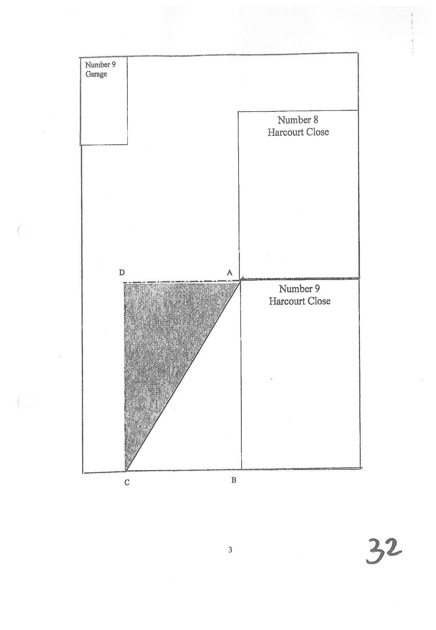
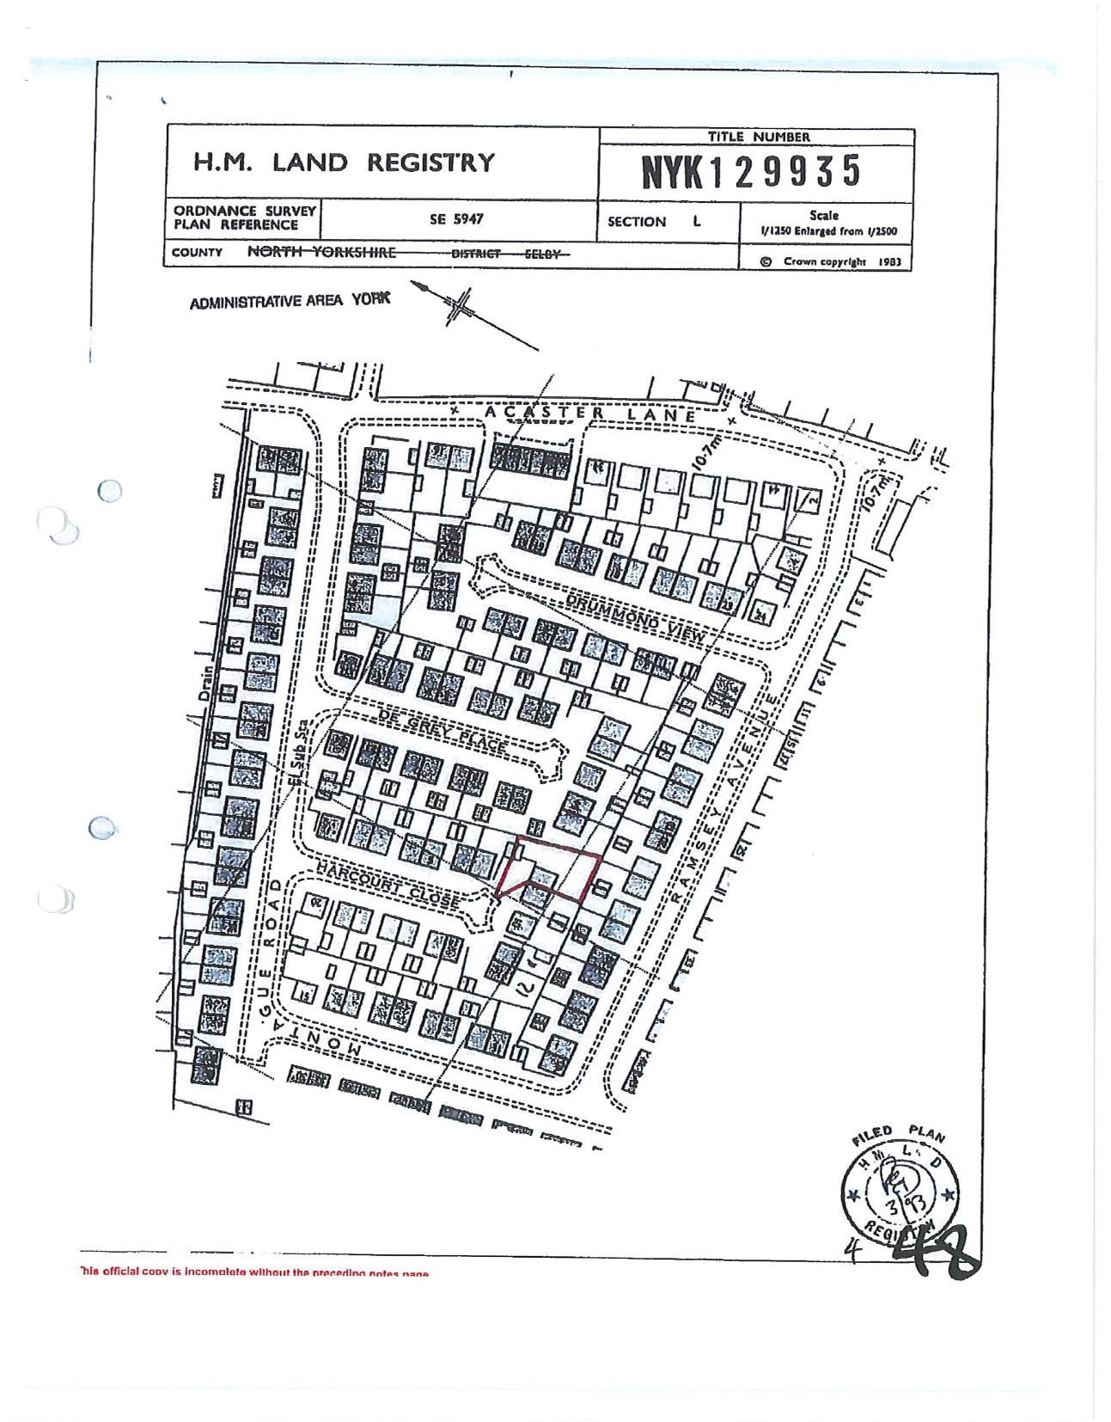
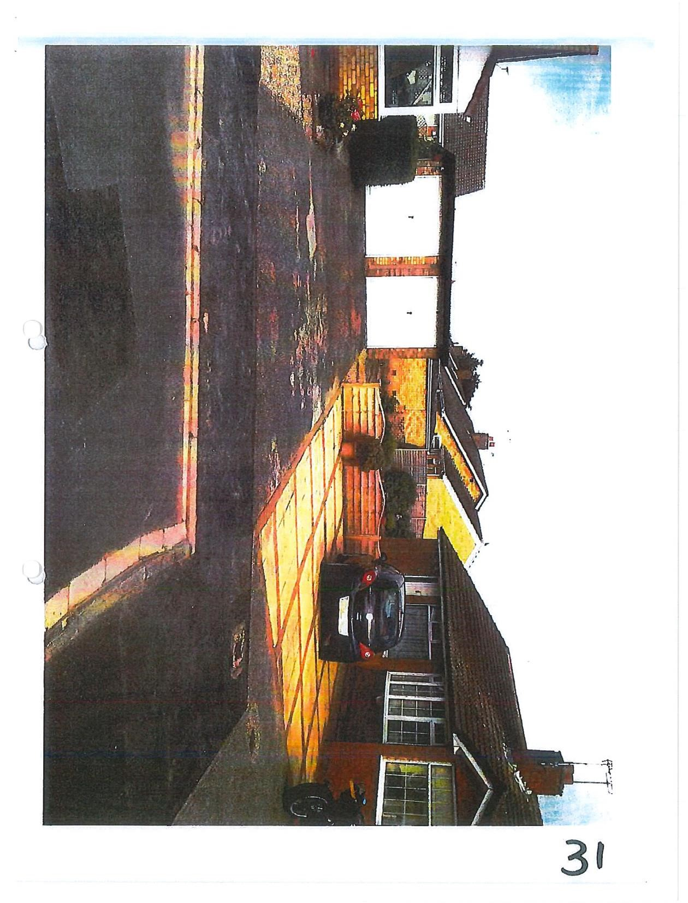
Judgment Approved by the court for handing down.

Thorpe and Frank & Anr

In fact, there had been no paving carried out in Kynoch’s case.
The reference to “the Red House Farms case” is to Red House Farms(Thorndon) Ltd. v Catchpole (unreported) November 12, 1976 Court of Appeal (Civil Division) Transcript No. 10A of 1977.

