UPPER TRIBUNAL (LANDS CHAMBER)



UT Neutral citation number: [2016] UKUT 0006 (LC)
UTLC Case Number: LCA/64/2014

TRIBUNALS, COURTS AND ENFORCEMENT ACT 2007

COMPENSATION – Flooding– claim for crop losses caused by diversion of floodwaters away from built property – whether respondent Council acting as lead local flood authority under the provisions of ss 14 and 14A Land Drainage Act 1991 – whether assistance from, and actions of, the Environment Agency and the Fire Service given as agents of the Council under doctrine of agency - compensation agreed at £14,500.

IN THE MATTER OF A NOTICE OF REFERENCE UNDER
SECTION 14(6) LAND DRAINAGE ACT 1991

BETWEEN ROBERT LINDLEY LIMITED Claimant

and

EAST RIDING OF YORKSHIRE COUNCIL Compensating
Authority

Re: Land at Maidensgrave Farm,
Burton Fleming, Driffield,
East Riding of Yorkshire.

Before :His Honour Judge Behrens and Mr P R Francis FRICS

Sitting at: Leeds Combined Court Centre, The Courthouse, 1 Oxford Row, Leeds
LS1 3BG
on
8 – 10 December 2015

John Bates (instructed by Crombie Wilkinson Solicitors LLP) for the Claimant
Andrew Scott (instructed by Forbes Solicitors) for the Acquiring Authority

© CROWN COPYRIGHT 2016

The following case is referred to in this decision:
Marriage v East Norfolk Rivers Catchment Board [1950] 1 KB 284

Abbreviations
- In this decision we adopt the following abbreviations:
Name | Abbreviation
Robert Lindley Ltd | The Company
Robert Lindley | Robert
Edward Lindley | Edward
East Riding of Yorkshire Council | The Council
Humberside Fire and Rescue Service | The Fire Service
The Environment Agency | The EA
The Land Drainage Act 1991 | The LDA 1991
The Flood and Water Management Act 2010 | The FWMA 2010
The Water Resources Act 1991 | The WR 1991
The Environment Act 1995 | The EA 1995
The Fire and Rescue Services Act 2004 | The FRSA 2004
The Upper Tribunal (Lands Chamber) | The UT
Litres per minute | l/m

Introduction
- This is a claim for compensation under ss.14A(11) of the LDA 1991. It arises as a result of serious flooding which occurred at Burton Fleming near Driffield between December 2012 and March 2013 when a water course known as the Gypsey Race which flows though the village overtopped.
- It will be necessary to trace the history of events in some detail. For the purpose of this introduction it is sufficient to note that from 24 December 2012 pumps were provided by the Fire Service and the EA in order to pump the flood water into the Gypsey Race. There is some dispute as to the extent of the Council’s involvement in the early stages. It is, however accepted that on 28 December 2012 Mr Skidmore, the then Head of the Council’s Streetscene Services, chaired a multi agency meeting in respect of the flooding. It is also accepted that from 2nd January 2013 the Council took over the supervision of the pumps supplied by the EA.
- The Gypsey Race flows through Burton Fleming from west to east. When leaving the village towards Maidensgrave Farm the watercourse flows to the east with Grindale road on the left bank and several fields including the Cottage Field on its right bank.
- Robert, his wife Sallyanne and his son Edward are the sole shareholders and directors of the Company which farms some 670 acres of land in the vicinity including Cottage Field. Cottage Field is a 30 acre field which at the material time contained a crop of carrots
- It is not in dispute that the Gypsey Race breached its banks adjacent to the Cottage Field with the result part of the Cottage Field suffered additional flooding and that part of the Company’s carrot crop was lost.
- The Company seeks to recover its loss from the Council. In the Statement of Case dated 4 July 2014 the loss was pleaded at £68,056.63. In his witness statement Edward sought to increase this figure £115,010.72. However shortly before the hearing the parties reached a compromise on the valuation of the claim. Subject to liability the loss has been agreed in the sum of £14,500 exclusive of interest. At the hearing we were told that the loss was agreed on the basis that an additional 2.9 acres had been flooded as a result of the pumping in Burton Fleming.
- Liability, however, remains very much in dispute.
- As noted above, the UT’s jurisdiction derives from s.14A(11) LDA 1991 which provides:
“(11) Section 14(5) and (6) applies in relation to the exercise by any authority of powers under this section as to the exercise of powers under section 14.”
Section 14(5) provides:
“Where injury is sustained by any person by reason of the exercise by a drainage board or local authority of any of their powers under this section, the board or authority shall be liable to make full compensation to the injured person.”
Under s.14(6) in case of dispute the amount of compensation is determined by the UT.
- The Council’s principal argument is that the Company’s loss was not sustained by reason of the Council’s exercise of its powers under ss.14 or 14A LDA 1991. They point to the fact that the pumping before January 2nd 2013 was carried out by the Fire Service and the EA. Mr Scott, accordingly submits that the Council was not exercising powers under either of the sections when the loss occurred.
- Mr Bates seeks to answer these points in a number of ways. He points out that the Council is the lead local flood authority for this stretch of the Gypsey Race. He submits that the EA and the Fire Service were assisting the Council in the exercise of its functions under s.14A LDA 1991. He submits that that the EA pumps were on loan to the Council from 26th December 2012, that the Council as the lead local flood authority entered into temporary agency agreements with the EA and the Fire Service. He relies on the doctrine of agency of necessity and ratification.
- We were told that this is in the nature of a test case in that there are a large number of other similar claims made by farmers as a result of crop losses allegedly caused by the pumping of flood waters. Thus, although the sums involved in this reference are now relatively modest the issues of principle involved will have a far reaching effect in respect of the other claims.

Witnesses
- Four witnesses gave evidence of fact on behalf of the Claimant – Edward and Robert together with Mr Keith Wells, chairman of Burton Fleming Parish Council who was heavily involved in matters connected with the flooding of the village, and Mrs Irene Pickering who was the local branch group secretary of the NFU. She attended a meeting between Edward, Robert, Mr Skidmore and other members of the multi agency meeting which took place at 14.00 on 28th December 2012.
- Seven witnesses of fact were called on behalf of the Council, all of whom were officers or employees. They comprised Mr John Skidmore, Mr Alistair Marr, Senior Land Drainage Engineer, Mr Alan Bravey, Emergency Planning Manager, Mr Andrew McLachlan, Flood Risk Strategy Manager, Mr Mike Pardoe, Assistant Engineer, Mr Mike Ball, Principal Engineer and Mr Russ Towse, Catchment Drainage Engineer. In addition we received witness statements from Mr Towle and Mr Harland who were not required to attend for cross-examination.
- All of the witnesses were plainly honest witnesses doing their best to assist the UT. There were in fact very limited disputes as to the primary facts. There was one dispute between Robert and Mr Skidmore as to whether Robert or Mr Skidmore suggested that the bank of the Gypsey Race be breached so that there would be further flooding of Cottage Field. As the suggestion was not pursued it is not necessary to resolve the issue. Our provisional view, however, is that it is unlikely that the suggestion would have come from Robert.
- There are a number of parts of the Council’s witness statements where after the event views are expressed as to which sections of which Act the relevant officer was acting under. With the greatest respect to the authors these statements are not matters of fact but expressions of opinion by unqualified persons. In those circumstances very little weight can attach to them.
- In addition to the witnesses of fact, the UT received detailed and very helpful expert reports from Dr Marta Roca, a Doctor in Civil Engineering employed as a specialist Flood Management Engineer by HR Wallingford for the claimant, and Mr Anthony Hardwick of JBA Consulting for the Council. We also received expert valuation evidence relating to the carrot crop from Mr Colin Noble of Vegetable Consultancy Services (UK) Ltd. As a result of the agreement between the parties none of the experts were called. However we have read the reports and utilised some of the non-controversial parts in the statement of facts.
- There are a number of contemporaneous documents which are relevant to the issues of fact that arise. These include a Flooding Diary of Events prepared by the Parish Clerk from contemporaneous notes, contemporaneous diary notes kept by Mr Skidmore, a contemporaneous log of the events of 26th December 2012 kept by the Fire Service and a letter from the EA dated 19 June 2015 but said to be based on the duty logs.

List of Issues
- The parties have helpfully set out an agreed list of seven issues for the UT to determine:
(1) What are the Respondent’s powers under section 14A of the Land Drainage Act 1991 in respect of the management of flood risk from surface water or an ordinary watercourse?
(2) If the Respondent was exercising these powers at the time the carrot crop was damaged, is it liable to pay compensation to the Claimant under section 14(5)?
(3) Does any other public body have similar powers to manage the risk?
(4) Under what statutory power did the Fire Service and/or the Environment Agency act?
(5) If a public body such as the Fire Service or the Environment Agency exercise powers under section 14A, do they do so as agents of the body empowered by section 14A?
(6) When did the damage occur?
(7) But for the Respondent’s statutory powers, would the damage be actionable at common law – trespass or nuisance – Marriage v East Norfolk Rivers Catchment Board [1950] 1 KB 284.

The facts

Plans
- In order to understand the facts better we have included in the Appendix three plans. Plan 1 shows Cottage Field in relation to the village and the route of the Gypsey Race from the west of Vicarage Close to the north and east of Cottage Field. Plan 2 shows the position of the Gypsey Race in Burton Fleming and the position of Rudston Bridge. Plan 3 shows where the pumps were on 27th December 2012. The photograph shows Cottage Field. All of the plans are taken from Dr Roca’s report.

The Gypsey Race
- The Gypsey Race drains an area of approximately 254 sq km at Bridlington. It rises from springs issuing from the basal chalk at Duggleby and Wold Newton. It is an unusual waterway since over its 41 km length there are few significant tributaries. It is classified as an intermittent stream as defined by the British Geological Survey.
- The Gypsey Race catchment is entirely underlain by the Cretaceous Upper Chalk. The chalk is the major aquifer of the region. The absence of surface water features is the result of highly permeable underlying geology.
- The earliest records of floods in Burton Fleming can be traced back to 1776. There are records of floods in 1853 and 1888. In his witness statement Robert refers to floods in 1947, 1962 and 2000.
- In paragraph 2 of his witness statement Mr Wells describes the position in this way:
“The Gypsey Race that flows through Burton Fleming is predominately a dry ditch and only starts to flow after a long period of prolonged rainfall. This happens very infrequently and sometimes not for a number of years. One or two houses alongside the Gypsey race are vulnerable to flooding but those houses are used to the fact and make preparations to alleviate the problem. The Gypsey Race usually bursts its banks at the height of the flow, but normally only spills out onto the adjoining highway. The last time I recall such extensive flooding was in the early 1960s.”
- December 2012 started largely dry but the last two weeks of the month saw the return of the sustained rainfall which was characteristic of much of the year since early April. Floodplain inundations were widespread across much of the UK. The wet December added to exceptional rainfall since March. In the chalk aquifer levels rose by more than 9m during the month in several boreholes and levels were well above average in all sites.

The Carrot Crop
- In paragraphs 2 to 10 of his witness statement Edward describes in detail the Company’s history in growing carrots. In the light of the compromise on valuation it is not necessary to describe this in detail. The Company started growing carrots in 2008 and had grown them every year between 2008 and 2012. In 2012 it drilled 88.25 acres hoping to yield 45 tonnes per acre. Some of these were drilled in the Cottage Field. A small proportion of the carrots were harvested in November 2012 to check their quality, sell as a November crop and make the field breaks to service the remaining carrots in the ground and appropriately cover them in polythene and straw. There was no problem with the carrots harvested in November.

Chronology of Events

19th and 20th December 2012
- Mr Skidmore became aware of a significant possibility of flooding in the County when he received an e-mail from the Flood Warning Duty Officer of the Flood Advisory Service. On 20th December he took part in a multi agency conference call chaired by the EA in which each organisation provided an update as to the actions they had taken, the outcomes and actions they were proposing to take.

Friday 21st December 2012
- It is clear from the Parish Diary that the Gypsey Race was overflowing by 10.04. A number of phone calls were made by the Parish Clerk requesting road closure signs and sandbags.
- Mr Skidmore took part in a multi agency conference at 09.45 when he was given a weather update from the Meteorological Office and the EA gave out a flood warning for 27th December 2012.
- At 14.45 Mr Skidmore took part in an internal conference call with Mr Ball (the Council’s Principal Engineer) and Mr Bravey (the Emergency Planning Manager). A number of areas were discussed including the Gypsey Race at Burton Fleming. Mr Skidmore’s diary note states that sandbags and flood boards were in place and the highway was passable with care
- At 16.49 Mr Skidmore received an email from Heather Wilson (another employee of the Council) confirming that the Gypsey Race was overflowing at Burton Fleming and that traffic had to drive very carefully.
- In his witness statement Robert states that only a small quantity of sandbags were delivered.

Saturday 22nd December 2012
- At 09.30 Mr Skidmore held a further call with Mr Ball. He was advised that there was no danger to properties and that all was calm.
- It is plain from the Parish Diary that by the evening there was concern about the flooding of properties. Between 19.50 and 20.52 the Parish Clerk made a number of phone calls to the Council and eventually to the Fire Service in relation to the lack of sandbags and the flooding of Primrose Cottage.
- In his witness statement Robert describes the flooding thus:
“ … however, this level of flooding occurs from time to time. It is an inconvenience to many residents but not a worry for most of the Village.”

Sunday 23rd December 2012
- According to the Parish Diary additional sandbags arrived but more were required.

Monday 24th December 2012
- According to the Parish Diary the Fire Service was present by 14.00 and had started pumping. The ditch (presumably the Gypsey Race) had been dug out. The water was pumped from the crossroads in the centre of the Village to the Rudston Road Bridge on the East side of the Village close to the Cottage Field.
- On 19 June 2015 Caroline Leach (the Principal Solicitor of the EA) wrote to the Council’s solicitor. The letter is based on conversations she had with Phil Edwards (a senior team leader with some involvement in the incident) and who had checked the duty logs and spoken to others involved. The letter includes the following:
“1. We received a request for assistance from [the Fire Service] on 24 December 2013 (sic). We initially indicated that we would be unable to help, but following further requests from [the Fire Service] we agreed to provide the loan of some of our pumps provided they were not subsequently required by us to deal with flooding from main river elsewhere. In providing this assistance we feel we acted within the spirit of the multi-Agency response required by [the CCA 2004] and in line with the Humber Local Resilience Forums Emergency Procedures …”
“2. Our records do not show who within [the Council] the initial request for assistance came from, but later in the event we spoke to both Steve Kidman and John Skidmore.”
- It is plain that the request did not come from Mr Skidmore who was not involved between 22nd and 27th December 2012. The Council have not adduced any evidence as to how the EA pumps came to Burton Fleming.
- According to the Fire Service its own pump was a Hydrosub 150 pump unit with a capacity of 7,000 l/m. According to Mr Skidmore the actual pumping was at the rate of 6,500 l/m. The Fire Service records show that pumping began at 20.10.

Christmas Day 2012
- Robert describes the situation as getting worse on Christmas Day. The Cottage Field began to flood with the Gypsey Race over topping its bank. He noticed that the flood water in the Village naturally crossed the road close to the Village Hall and then flowed through the Company’s fields to the North of Grindale Road. These fields are known as 1st and 2nd Gravels. The flood water then crossed the road as the Gypsey Race turns into Cottage Field.

Wednesday 26 December 2012
- Three pumps from the EA were set up and started pumping. This increased the total pumping capacity of the pumps (3 from the EA and one from the Fire Service) to 29,000 l/m.
- The Fire Service contemporaneous log for this day has been disclosed. Some of it is relevant to the issues with which this case is concerned:

Time | Entry
13.55 | Someone has drove over the [EA] hose and it is now split. CVan we request some more hose at least 2 lengths.
14.17 | … Mike Pardoe has also been contacted by [the EA] to see about the extent of the damage to the hose.
14.24 | From [the EA] – It should be [the Council] that deal with this issue. They are just lending a hand and this is not a priority for them. …
15.24 | [the Fire Service pump] will remain in place until 0200 27 Dec 2012. …  Ron Johnson EA Duty Officer advises that this is local authority responsibility however they will maintain 2 pumps at this incident unless greater need arises elsewhere within region. Mike Pardoe, local authority duty officer confirmed local authority responsibility and that they will arrange additional resources for a m 27th Dec 2012 with a view to [the Fire Service pump] withdrawing.  Local farmer raised concerns that as [the Fire Service] and EA have increased pump operations this is affecting his carrot crop downstream. Mike Pardoe of [the Council] advised that residential properties in Burton Fleming are a higher priority. Therefore pumping operations will continue. …
- Mr Pardoe was an Assistant Engineer and the operations supervisor who was the duty officer for Boxing Day. He accepted that he must have received a call out and that he responded by visiting Burton Fleming. On visiting the site he assessed that more sandbags were required and made arrangements for them to be to be delivered. He had no recollection of any discussions with the EA or with the Fire Service along the lines contained in the Fire Service log. He does not have a decision making function within the Council and does not believe that he advised that the Council were responsible.
- In paragraph 15 of his witness statement Robert describes how the Company hire a digger from a local plant hire company to dig trenches to protect the carrots:
“We dug a trench running roughly parallel to the Gypsey Race and placed the soil from it between the trench and the Gypsey Race itself to try and help keep the water within the Gypsey Race. This channel went back into the Gypsey Race in Field 1 where we were able to breach the banks of the Race to allow the water to flow back into it. The water continued to overtop the Gypsey Race in any event but the trench along side the Gypsey Race filled up thus going some way to minimise flooding in Cottage Field. The Gypsey Race did not overtop towards the road. Grindale Road was only flooded by the Village Hall and to the East where the flood water crossed from Gravels to Maidensgrave Farm. We dug a trench along the field break …. This trench was dug so that water could flow from smaller breaks and trenches running North to South in between the rows of polythene into the trench we dug parallel to the Gypsey Race then into the Gypsey Race in the Stubble Field. The trenches were effective because the water was going into Cottage Field by overtopping the Gypsey Race because the Gypsey Race could not cope with the volume of water being pumped into it. … The level of water in the village worsened considerably.”

Thursday 27th December 2012
- Mr Skidmore became involved with the situation again from about 9.00. After conducting a radio interview with radio Humberside he held an internal conference call with other officers at 13.00. Thereafter at 14.17 he sent an email to relevant parties summarising the situation. He made the point that Burton Fleming was the worst affected area with water flowing from fields and springs due to the aquifer levels. He pointed out that there are 343 houses in Burton Fleming and that water was flowing in the main street. Over 1,000 sandbags had been delivered and 200 more were to be delivered that day. He stated:
“I have been liaising with the EA and [the Fire Service] throughout today to best deploy resources across the East Riding. The EA are delivering 2 pumps to Burton Fleming this afternoon so [the Fire Service] can redeploy the 2 pumps they have on site.”
- There may be some confusion over the final sentence in that the Fire Service only had one pump. It may be that the 3 EA pumps were not all delivered on 26 December. There is a reference in the Parish Diary to a further pump being expected from the EA.
- In his witness statement Robert states that the level of water in the village and Cottage Field worsened.

Friday 28th December 2012
- At 01.39 the Fire Service removed their pump until 15.16 the same day as it was needed elsewhere.
- Robert describes the flooding in the village as “desperate” with 7 or 8 homes flooding and the sewage system failing.
- At 11.45 Mr Skidmore chaired a multi-agency meeting in Burton Fleming village hall. This included the Fire Service, the EA, the Police and Council staff. The purpose was to receive a situation update from all agencies and to consider future actions. According to Mr Skidmore particular concerns were raised regarding a care home in the village and whether this might need to be evacuated due to the rising water.
- Mr Skidmore describes his view of his role in paragraphs 36 and 40 of his witness statement thus:
36 “… I must confirm that at this time or any other stage subsequently I did not consider it was the Council’s duty or responsibility to undertake any kind of assessment in relation to the pumping works. As far as I was concerned the Fire Service and Environment Agency were doing the best that they could in difficult circumstances using the available resources.”
40. “I confirm that I Chaired the site meeting but no single Agency took control of the tasks to be undertaken but through the course of discussions and briefings the various Agencies agreed which organisation would undertake the various tasks required.”
- In cross-examination Mr Skidmore was referred to the Humber Local Resilience Forum Emergency Procedures Manual. He indicated that he was following the principles set out in that manual though he did not consider that this was an emergency within the strict definition in that Manual.
- Following the multi-agency meeting at about 14.00, Robert, Edward, Mrs Lindley, and Mrs Pickering had a meeting at the village hall with Mr Skidmore and other persons who had been present at the multi agency meeting. There is a conflict as to precisely what was said at the meeting. Mr Skidmore describes it as heated and that Robert became agitated. It is common ground that the question of permitting the carrot field to flood was raised and not accepted. There are disputes which we do not need to resolve as to whether it was Robert or Mr Skidmore who made the suggestion. In any event Robert then suggested that the water be pumped down Rudston Road and permitted to flood a stubble field immediately to the south of Cottage Field. Edward and representatives from the Fire Service and the Council went to visit the field to see if the suggestion was viable. It was, however rejected by the Fire Service on the ground that they did not have enough hose. There is no doubt that Robert was (and is) unhappy at that decision.
- Amongst the matters discussed that day was the question of fuel for the EA pumps. It is not in dispute that Mr Skidmore agreed to provide the fuel. There was an exchange of emails between 15.51 and 16.09 that make it clear that fuel for the pumps would be delivered at about 18.30 that day. It is not in dispute that all subsequent fuel was provided by the Council. In her letter dated 19 June 2015 Caroline Leach puts the matter thus:
“We take the view that the operation of the pumps was either carried out directly by [the Council] (who on our records show were refuelling the pumps from 26 December 2013) or where any actions were carried out directly by [the EA] we did so acting on behalf of [the Council] …”
- The records of the EA have not been disclosed. As the pumps were not delivered until 26th or 27th December it seems likely that that they were full of diesel on arrival and that the first delivery of fuel was on 28 December in accordance with the emails referred to above. All subsequent refuelling was carried out by the Council.

29 to 31 December 2012
- The situation continued to deteriorate until 30th or 31st December 2012. All parties agree that the peak of the flood occurred on that date and this is supported by the water levels reported at the Willy House station some 1.5 km upstream of Burton Fleming. It is supported by the evidence of Edward, Robert and Mr Ball on behalf of the Council. Mr Ball made a chalk mark on Rudston Bridge to denote the high point.
- Pumping continued throughout this period.
- In his witness statement Robert describes his efforts to dredge the Gypsey Race and the fact he was given permission to dredge back to Rudston Road Bridge and Burton Fleming.
- Mr Skidmore was on site for all of 29th December 2011. He held multi agency meetings and updated residents on the situation. He also spoke to the media.
- It is Mr Skidmore’s view that he was coordinating the multi agency response. He was not acting under any specific power. As co-ordinator he said he was not in charge of the other agencies.

Subsequent events
- At 11.18 on 1st January 2013 the Fire Service removed its pump and had no further involvement.
- On 2nd January 2013 the Council accept that they took over the EA pumps and all further pumping was carried out by it. The Parish Diary records that they were moving into the recovery phase.
- Pumping continued until early March 2013. On 12th March 2013 the Parish Council minutes record that the water in the Gypsey Race continues to recede and the pumps have now been removed.
- Following the flooding Mr Towle, a Senior Engineer employed by the Council prepared a Flood Investigation Report in relation to the flooding at Burton Fleming. Although the report refers to s 19 of the FWMA 2010 it goes far further than the obligations under s 19 in that it contains a detailed investigation of the Flooding and made a number of recommendations designed to improve the flood resilience of the Gypsey Race.

Damage to the Carrot Crop
- It was common ground between the parties that the carrot crop was damaged within 48 hours of being flooded. It was also common ground that, subject to liability, compensation would only be payable for the additional damage to the carrot crop caused by the additional flooding of Cottage Field resulting from the pumping of the flood water into the Gypsey Race. In so far as Cottage Field would have flooded in any event no compensation would be payable. It is not, of course, necessary to for the UT to determine the extent of that additional damage because of the compromise between the parties.
- Mr Bates submitted that the damage occurred between 28th and 31st December 2012. Those were the days when the flood was at its height and thus the days when the flood of Cottage Field was at its worst.
- In his closing submissions, having heard the evidence of Mr Ball and Robert, Mr Scott accepted that those were the most likely dates for the additional damage to the carrot crop.
- In those circumstances we accept the submissions of Mr Bates and find as a fact that the additional damage to the carrot crop occurred between 28th and 31st December 2012.

Findings of Fact
- As noted earlier in this decision there were very few disputes of fact between the parties. All of the witnesses were honest and doing their best to assist the Tribunal. In those circumstances very considerable weight has to be given to the contemporaneous documents.
- For the reasons set out above we do not find it necessary to decide whether the Council or Robert suggested the deliberate flooding of Cottage Field. The 28th December was an anxious time for all and there may well have been a misunderstanding as to what was being suggested.
- We accept that the Fire Service’s log of the events of 26th December 2012 is accurate and that the conversations which are recorded took place. It is unsurprising that Mr Pardoe cannot now remember details of the conversations he had on that date. There is no reason to doubt the accuracy of the log.
- The status of Caroline Leach’s letter of 19 June 2015 is more controversial. It is not a contemporaneous document. On the other hand it is based on the EA’s records and on conversations with a person who was involved and who has spoken to others who were also involved. The records have not been produced and neither side chose to call any evidence from the EA. On the other hand there is no evidence at all from either side as to how the EA became involved. On balance and with some hesitation we accept Caroline Leach’s account as to how the EA became involved.
- There is no dispute that the EA loaned the pumps to the Council after 2nd January 2013. There is, however, an issue whether they are to be taken to have loaned them from 26th December 2012. We shall deal with this later in the decision.

The Legal Position
- We are greatly indebted to the clear and extremely helpful skeleton argument and oral submissions of Mr Bates in relation to the law of flood management and the duties and powers of local authorities, the EA, and the Fire Service where there are floods. This section of the decision owes much to those submissions.

The FWMA 2010
- The starting point is to consider the powers and structures of the FWMA 2010.
- Part 1 of the FWMA 2010 contains the key concepts and definitions. These include the definitions of a flood, risk, risk management and lead local flood authority. It is common ground that the flood in Burton Fleming in December 2012 was a flood within s.1 and that the Council was the lead local flood authority within s.6(7). A flood risk management function is defined in s.4(2) as:
“(a) a function under this Part,
(b) a function under section 159 or 160 of the Water Resources Act 1991,
(c) a flood defence function within the meaning of section 221 of that Act,
(d) a function under the Land Drainage Act 1991,
(e) a function under section 100, 101, 110 or 339 of the Highways Act 1980, and
(f) any other function, under an enactment, specified for the purposes of this section by order made by the Minister.”
- This case is primarily concerned with the functions under the LDA 1991 though some mention will have to be made of the EA’s functions and powers to carry out flood management works.
- A risk management authority is defined in s. 6(13) as comprising:
“(a) the Environment Agency,
[(aa) the Natural Resources Body for Wales,]
(b) a lead local flood authority,
(c) a district council for an area for which there is no unitary authority,
(d) an internal drainage board,
(e) a water company, and
(f) ….a highway authority”
- In this case the only relevant risk management authorities are the Council (as the lead local flood authority) and the EA. It is to be noted that the Fire Service is not a risk management authority.
- Under s.9 a lead local flood authority must develop, maintain, apply and monitor a strategy for local flood risk management in its area. This includes flood risks from ordinary watercourses. There are detailed provisions in s.9(4) as to what the strategy must specify and there is a requirement in s.9(7) to publish a summary of its strategy.
- Under s.13(1) there is a duty on a relevant authority to co-operate with other relevant authorities in the exercise of their flood erosion risk management functions. Under s.13(4) a risk management authority may arrange for a flood risk management function to be exercised on its behalf by another risk management authority.
- In the course of his submissions Mr Bates submitted that s.13(4) contemplated some sort of formal agreement between risk management authorities although he acknowledged that there was nothing in the wording of the subsection to support this. Whilst I see the force of Mr Bates’s submission it is unnecessary for us to decide whether it is correct. Mr Scott did not suggest that there was an arrangement between the EA and the Council within s.13(4).
- S.19 places an investigatory role on the lead local flood authority in the following terms:
“(1) On becoming aware of a flood in its area, a lead local flood authority must, to the extent that it considers it necessary or appropriate, investigate--
(a) which risk management authorities have relevant flood risk management functions, and
(b) whether each of those risk management authorities has exercised, or is proposing to exercise, those functions in response to the flood.
(2) Where an authority carries out an investigation under subsection (1) it must--
(a) publish the results of its investigation, and
(b) notify any relevant risk management authorities.”
- A number of points need to be made about s.19. The duty arises as soon as the lead local flood authority becomes aware of a flood in its area. The section contemplates that at that stage a risk management authority may have relevant flood risk management functions. Mr Bates points out that this clearly contemplates that there may be some temporary measures to be taken which fall within the definition of risk management functions. Thus, he submits that it is unlikely that Parliament intended that only permanent long term measures should be within the definition.
- Second, it is to be noted that the duty under s.19 is quite limited. It is only obliged to carry out the investigation to the extent it considers it necessary or appropriate. The duty is limited to investigating which are the relevant risk management authorities and whether each of those authorities is proposing to exercising its functions.
- As we have indicated the report prepared by Mr Towle is a valuable document. It is highly relevant in respect of the Council’s duties under s.9. It is not, however, an investigation under s.19. It was not carried out at the time of the flood and does not purport to deal solely with the matters directed by s.19.
- There is no doubt that the officers of the Council were aware of the existence of s.19. There is a reference to it in Mr Skidmore’s diary for 28th December 2012. It is referred to in Mr Towle’s report. However it seems that they misunderstood the purpose and effect of s.19. Certainly there is no evidence that anyone on behalf of the Council carried out an investigation as to who were the relevant risk management authorities or whether anyone considered whether such an investigation was appropriate or necessary. It may be that if such an investigation had been carried out there would have been less confusion about precisely what powers were being exercised.
- The heading of Schedule 2 of the FMWA 2010 is “Risk Management: Amendment of Other Acts”. Paragraphs 25 to 39 deal with amendments to the LDA 1991. Paragraph 29 inserts a new s.14A in the following terms:
“(1) A lead local flood authority may carry out flood risk management work if Conditions 1 and 2 are satisfied.
(2) An authority listed in subsection (3) may carry out flood risk management work if--
(a) Conditions 1 and 3 are satisfied, or
(b) Conditions 1 and 4 are satisfied.
(3) The authorities are--
(a) an internal drainage board,
(b) a district council, and
(c) a lead local flood authority for an area for which there is no district council.
(4) Condition 1 is that the authority considers the work desirable having regard to the local flood risk management strategy for its area under section 9 or 10 of the Flood and Water Management Act 2010.
(5) Condition 2 is that the purpose of the work is to manage a flood risk in the authority's area from--
(a) surface runoff, or
(b) groundwater.
(6) Condition 3 is that the purpose of the work is to manage a flood risk in the authority's area from an ordinary watercourse.
(7) In subsection (6) the reference to an ordinary watercourse includes a reference to a lake, pond or other area of water which flows into an ordinary watercourse.
(8) Condition 4 is that the purpose of the work is to manage a flood risk in the authority's area from the sea and either--
(a) the work is within subsection (9)(a), (b) or (f), or
(b) the Environment Agency has consented to the work.
(9) In this section "flood risk management work" means anything done--
(a) to maintain existing works (including buildings and structures) including cleansing, repairing or otherwise maintaining the efficiency of an existing watercourse or drainage work;
(b) to operate existing works (such as sluicegates or pumps);
(c) to improve existing works (including buildings or structures) including anything done to deepen, widen, straighten or otherwise improve an existing watercourse, to remove or alter mill dams, weirs or other obstructions to watercourses, or to raise, widen or otherwise improve a drainage work;
(d) to construct or repair new works (including buildings, structures, watercourses, drainage works and machinery);
(e) for the purpose of maintaining or restoring natural processes;
(f) to monitor, investigate or survey a location or a natural process;
(g) to reduce or increase the level of water in a place;
(h) to alter or remove works.”
(10) Nothing in this section authorises a person to enter land except for the purpose of maintaining existing works.
(11) Section 14(5) and (6) applies in relation to the exercise by any authority of powers under this section as to the exercise of powers under section 14.
(12) The powers under section 62 and 64 are available to an authority for a purpose in connection with the exercise of powers under this section.
(13) In this section the following terms have the meaning given by Part 1 of the Flood and Water Management Act 2010--
(a) flood risk,
(b) lead local flood authority,
(c) surface runoff, and
(d) groundwater."
- This section is central to Mr Bates’s submissions. It is common ground that the relevant part of the Gypsey Race is “an ordinary watercourse”. He submits that the pumping was flood risk management work within ss.(9)(g). It was work to reduce the level of water in the centre of Burton Fleming. He submits that Conditions 1 and 3 were satisfied; the Council must have considered the pumping desirable having regard to the local flood risk strategy. Furthermore the purpose of the pumping was to manage the flood risk from the Gypsey Race which had flooded into Burton Fleming. Accordingly he submits the pumping was carried out in exercise of the powers under s 14A.
- Mr Scott rejects this submission. He made no submissions as to Conditions 1 and 3. However he submitted that temporary pumping was not within ss.(9)(g). He submitted that flood risk management work within ss.(9) had to be work of a permanent nature and thus did not include temporary pumping of water.
- There are a number of difficulties with Mr Scott’s submission. First, there are no express words in the definition limiting the work to permanent work. Second, s.9 uses the expression “anything done”. These are very wide words. If Parliament had intended to limit the definition of flood risk management work to permanent work it would not have chosen those wide words. Third, as Mr Bates pointed out, s.19 clearly contemplates that when a flood occurs some risk management authorities will have relevant flood risk management functions, some of which are likely to be temporary. Fourth, despite every encouragement from Mr Bates, Mr Scott was not able (or chose not) to point to any other statutory basis for the pumping by the Council. Mr Bates drew our attention to paragraphs 1-19 to 1-24 of Cross on Local Government Law as authority for the proposition that:
“A public body, incorporated by statute, may only exercise the powers granted to it by that statute expressly or impliedly or do whatever is reasonably incidental to the exercise of such powers.”
- We have no hesitation in preferring the submissions of Mr Bates. In our view the pumping by the Council was a flood risk management work within ss.(9)(g). In our view the definition of flood risk management work in ss.(9) is wide enough to include temporary as well as permanent work. The use of the expression “anything done” is to our minds conclusive.
- Mr Scott also submitted that the pumping that caused the additional damage to the carrot crop was not carried out by the Council. We will deal with that submission later in the decision.

The Environment Agency
- Paragraphs 40 to 49 of Sch 2 of the FMWA 2010 contain amendments to the WRA 1991. Paragraph 47 contains an amendment to s.165(1) which deals with the EA’s power to carry out works. It provides:
“(2) For subsection (1) substitute--
"(1) The Agency may--
(a) carry out flood risk management work within subsection (1D)(a) to (f) if Conditions 1 and 2 are satisfied;
(b) carry out flood risk management work within subsection (1D)(g) or (h) if Condition 1 is satisfied.
(1A) Condition 1 is that the Agency considers the work desirable having regard to the national flood and coastal erosion risk management strategies under sections 7 and 8 of the Flood and Water Management Act 2010.
(1B) Condition 2 is that the purpose of the work is to manage a flood risk (within the meaning of that Act) from--
(a) the sea, or
(b) a main river.
(1C) In subsection (1B)(b) the reference to a main river includes a reference to a lake, pond or other area of water which flows into a main river.
(1D) In this section "flood risk management work" means anything done--
(a) to maintain existing works (including buildings or structures) including cleansing, repairing or otherwise maintaining the efficiency of an existing watercourse or drainage work;
(b) to operate existing works (such as sluicegates or pumps);
(c) to improve existing works (including buildings or structures) including anything done to deepen, widen, straighten or otherwise improve an existing watercourse, to remove or alter mill dams, weirs or other obstructions to watercourses, or to raise, widen or otherwise improve a drainage work;
(d) to construct or repair new works (including buildings, structures, watercourses, drainage works and machinery);
(e) for the purpose of maintaining or restoring natural processes;
(f) to monitor, investigate or survey a location or a natural process;
(g) to reduce or increase the level of water in a place;
(h) to alter or remove works."
- It is to be noticed that the provisions have some similarity with those in s.14A of the LDA 1991. It is also to be noted that 2 conditions have to be satisfied to enable the EA to carry out most of the flood risk management work set out in ss (1D). However to carry out work under ss (1D)(g) (which would include pumping water) it is only necessary for Condition 1 to be satisfied. However for Condition 1 to be satisfied the EA has to be satisfied that the work desirable having regard to the national flood and coastal erosion risk management strategies. This is, of course, to be contrasted with Condition 1 in section 14A of the FWMA 2010 which refers to the local flood risk management strategy. There is no suggestion that the pumping out of Burton Fleming was in accordance with the national strategies of the EA.
- It follows (though not for quite the same reason as is in paragraph 19 of Mr Bates’s skeleton argument) that we agree that the EA did not have power to pump water under s.165 of WRA 1991 (as amended).
- As noted above the EA is a risk management authority within s.6(13) of the FWMA 2010 and is under a duty to co-operate with the Council in the exercise of its flood risk management functions. Furthermore under s.37(3) of the EA 1995 the EA have power to provide advice or assistance to any person.
- In the light of the matters contained in the Fire Service’s log of 26 September 2012 and in Caroline Leach’s letter of 19 June 2015 it seems to us that the proper analysis of the position is that the EA were co-operating with and giving assistance to the Council in the exercise of its flood risk management functions under the FWMA 2010.

The Fire Service
- The legal position of the Fire Service is different from that of the Council or the EA. It is not a relevant authority. S.11 of the FRSA 2004 confers wide powers on the Fire Service in the following terms:
“(1) A fire and rescue authority may take any action it considers appropriate--
(a) in response to an event or situation of a kind mentioned in subsection (2);
(b) for the purpose of enabling action to be taken in response to such an event or situation.
(2) The event or situation is one that causes or is likely to cause--
(a) one or more individuals to die, be injured or become ill;
(b) harm to the environment (including the life and health of plants and animals).”
- There can be little doubt that the flooding in Burton Fleming was an event within ss..(2)(a).
- In a letter dated 6th July 2015 Tim Kelly, the Fire Service’s Director of Public Safety expressed the view that the Fire Service acted under s.11 of the FRSA 2004. We agree that the pumping by the Fire Service was carried out under this section.
- It follows, in our provisional view, that any damage to the carrot crop caused by the Fire Service was not an injury sustained by the Company by reason of “the exercise by any authority of powers under section 14A” so as to be within the jurisdiction of the UT.
- It is not, however, necessary for us to reach a final conclusion on this point because Mr Scott very helpfully indicated that the point was covered within the compromise agreement between the parties. If liability is established he accepted that the compensation was to be assessed in the sum agreed notwithstanding that some of the injury was caused by pumping from the Fire Service.

Compensation
- Compensation under s 14A (11) LDA 1991 is payable in respect of (a) an injury to the Company caused by (b) the exercise by any authority of its powers under s 14A.
- In his skeleton argument Mr Bates drew our attention to Marriage v East Norfolk Rivers Catchment Board [1950] 1 KB 284 where Tucker LJ stated at 292:
“It is well settled that under language such as is used in s.34, sub-s.3, a claimant for compensation must prove that the act complained of is one which, but for the authorization of the statute, would have been actionable.”
- The reference in Tucker LJ’s judgment was to the Land Drainage Act 1930. S.34(3) of that Act is not materially different from s.14(5) of the LDA 1991.
- Mr Bates referred us to paragraphs 20.07 and 20.08 of the 21st Edition of Clerk & Lindsell on torts and submitted that the sending of more water into a watercourse than it can contain so that flooding occurs on a Claimant’s land would be a nuisance by encroachment and thus would have been actionable. Mr Scott made no submissions on this part of the case and it is thus not necessary to consider it in more detail. We accept Mr Bates’s submission that the pumping would have been actionable at common law.
- Accordingly, in our view, the Company suffered an injury within the meaning of the section.
- There remains the question of whether the injury was sustained by the exercise by the Council of its powers under s.14A. Mr Scott argued forcefully that it was not. He submitted that the relevant pumping was carried out before 31st December 2012 and that this pumping was carried out by the EA.
- We do not accept that argument for two reasons. We accept that relevant pumping took place before 31st December 2012. However in our view the pumps were on loan to the Council from 26th or 27th December 2012. This is the view of the EA and we agree with it. There is no doubt that the pumps were on loan after 2nd January; thus there plainly was a loan. All of the fuel for the pumps was paid for by the Council including the fuel for the period when the EA were on site. Whilst the pumps may have been supplied full at the beginning of the loan they may also have been returned full at the end. The EA received a request for assistance from the Council prior to the supply of the pumps and agreed to provide pumps in response to that request. It was clear from the evidence of Mr Towse that very little supervision was required in the operation of the pumps. Once they were in position all that was necessary was to ensure they had sufficient fuel. In our view the correct inference from these facts is that the pumps were loaned to the Council from the time they were delivered.
- For the reasons set out above we consider that the EA was assisting the Council in fulfilling its flood risk management work under the FWMA 2010 and that the pumping of the water in Burton Fleming was flood risk management work within s.14A LDA 1991. We therefore consider that, as a matter of construction of s.14A(11), the injury suffered by the Company was caused by the exercise of the Council’s powers under s.14A irrespective of whether the loan of the pumps is taken to have started prior to 31st December 2012.
- In the course of argument Mr Bates suggested another ground upon which compensation was payable. He submitted that the EA was acting as the Council’s agent and/or that the agency had been ratified by the Council. That argument gave rise to difficult questions under the doctrine of agency of necessity and ratification. In the light of our views it is unnecessary to decide them and we prefer therefore not to do so.

Conclusion
- In our view this claim succeeds and the Company is entitled to compensation in the agreed sum of £14,500 together with interest.
- We believe we have answered all the questions posed in the list of issues. In case we have not a summary of our determinations is:
(1) The pumping of water at Burton Fleming was an exercise of the power under s.14(A)(9)(g).
(2) Yes
(3) There is no evidence that the EA considered it desirable having regard to the national flood and coastal erosion risk management strategies. No detailed consideration was given as to whether any of the authorities mentioned in s.14A(3) might have had power to carry out flood risk management work.
(4) The Fire Service acted under s.11 of the FRSA. The EA acted under s.13(1) of the FWMA 2010 and/or s.37(3) of the EA 1995.
(5) The Fire Service was not acting as the Council’s agent. It is unnecessary for us to decide whether the EA was acting as the agent of the Council.
(6) Between 28th and 31st December 2012
(7) Yes.
- This decision determines the issues before us and is final in all respects other than the costs of the reference. The parties may now make submissions on such costs and a letter giving directions for the exchange of submissions accompanies the hard copy of this decision.
DATED: 11 January 2016
HHJ John Behrens
P R Francis FRICS

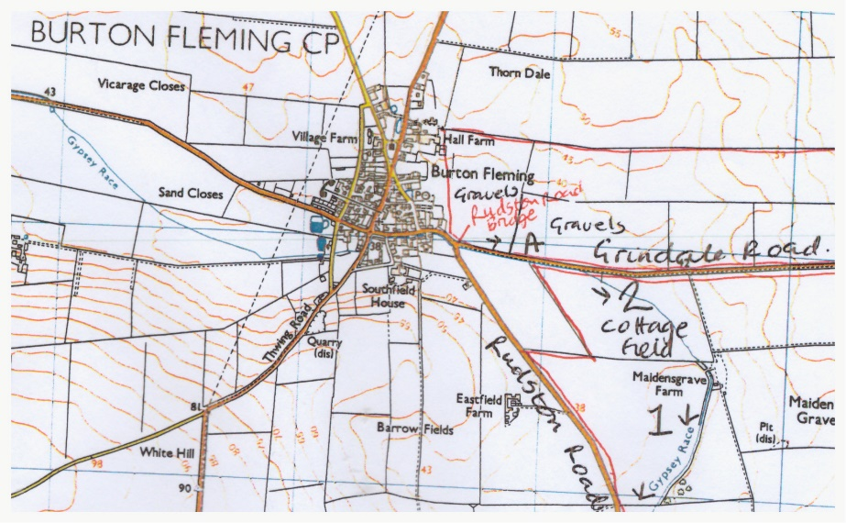
APPENDIX

Map of Area

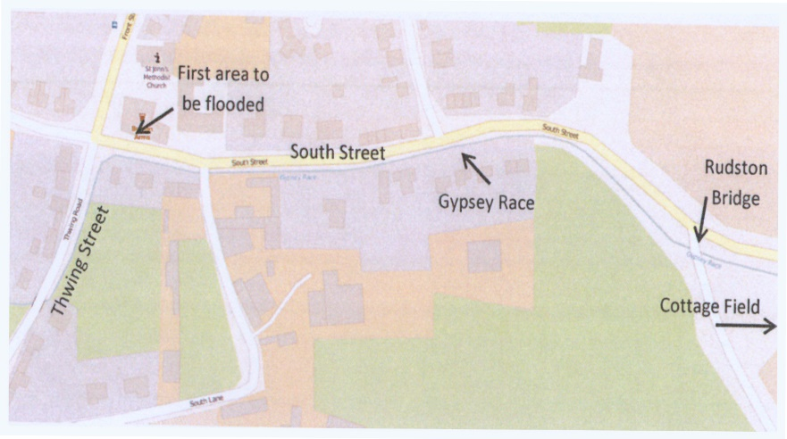

South Street and Gypsey Race

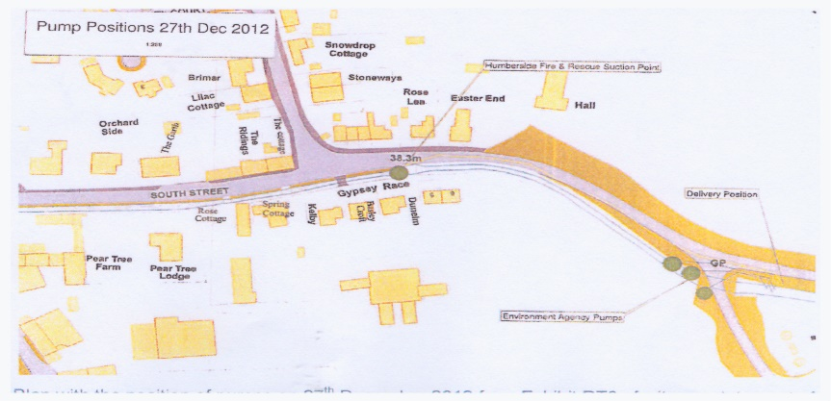

Position of Pumps on 27 Dec 2012

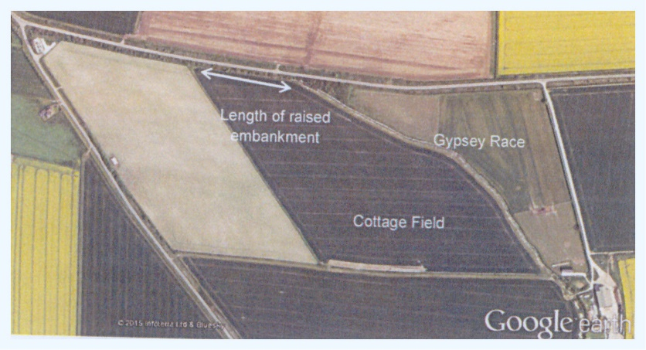

Cottage Field and Gypsey Race

